QUESTION A

: i) Find the total feeding time for all of the rare animals.

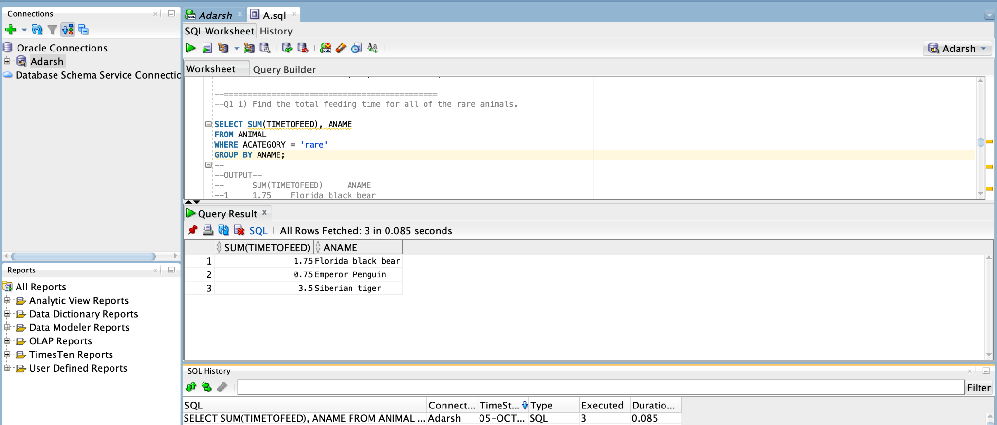

================================================================================================================================================

ii) Which animal(s) have a `time to feed' larger than every rare animal? Give the id and name of the animal.

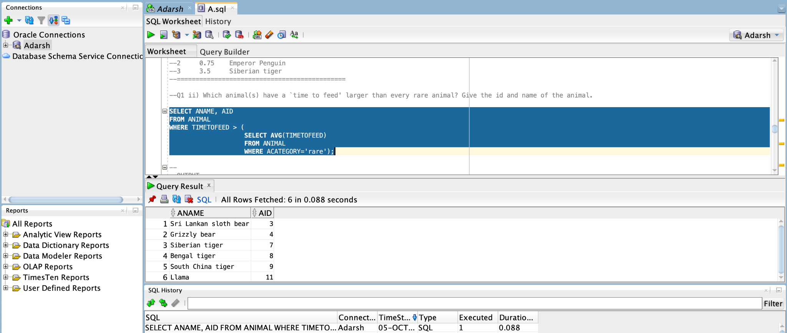

iii) Name zookeepers handling at least 4 animals.

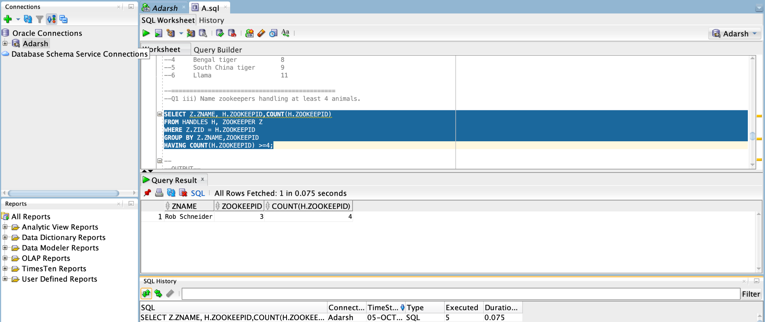

================================================================================================================================================

iv) Find the names of the animals that are not related to the bear.

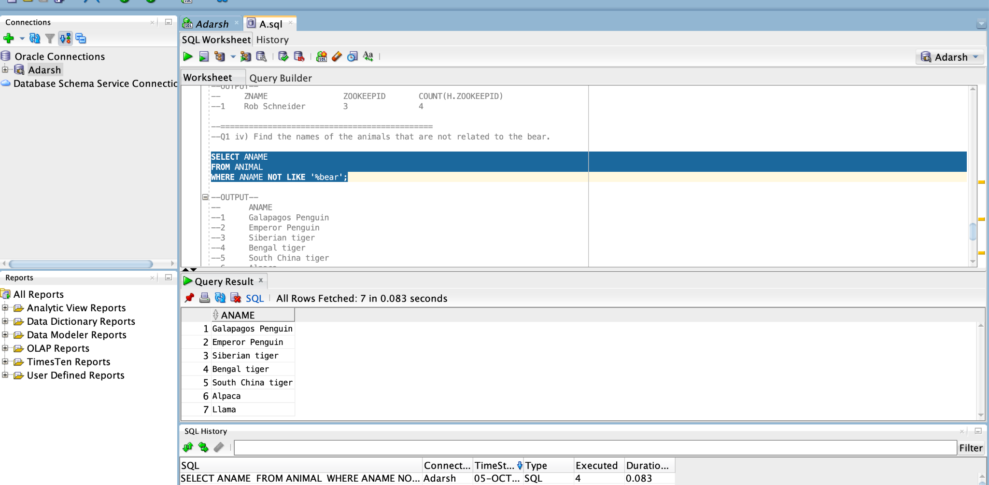

v) List zookeepers earning the most while feeding animals.

